**20.1.1**

How are you Khae?

I'm good. I have a lot of things to do. I can't do them on weekdays, so I have to do them on the weekend

What do you have to do today?

First, I need to go to the bank to get money. Then I have to go to the mall, to buy new clothes

I love the mall. Why do you need new clothes?

It's for work! I need to buy a dress and some trousers. The boss say, we have to wear business clothes. I can't wear jeans

Do you have to go to other store?

Yes, after the mall, I need to go to the post office, to mail a package to my family in Thailand. Last, I have to go to the super market to get food for this week

Woa, that are a lot of things to do

I know

Would you buy me some apples at the suppermarket?

Yes, no problem

Oh, can you mail the letter for me at the post office

OK

Please, get me give you some money. Keep the change

Thank you Mrs. Berry

I don't need to go to the bank now

You can use that money pay for the taxi or the subway

Good idea, I want to take the subway

Have a good day, see you later

See you leter

What are Khae and Mrs. Berry talking about?

* Khae’s busy day.

Khae needs to buy new clothes for her job.

What does Khae need to send at the post office?

* Something to her family.

What does Mrs. Berry want Khae to buy for her?

* Fruit

What does Mrs. Berry give Khae?

* Money

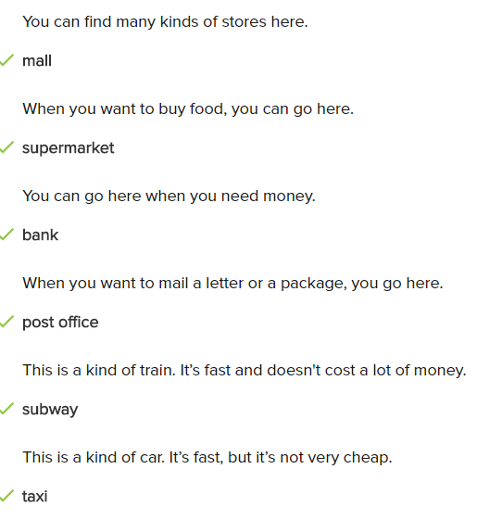

What does the woman want to take?

* She can take the subway.

Where does the man want to go?

* Bank

Where is the woman?

* Mall

Where does the man need to go?

* Supermarket

How does the woman want to go to the mall?

* Taxi